Magnus Nmonwu
Regional Director: Sage West Africa
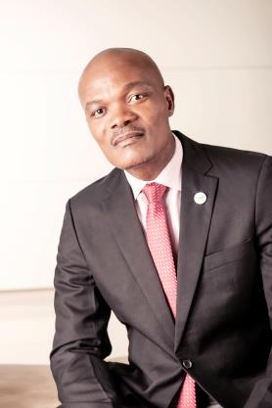
Magnus Nmonwu is responsible for the growth and positioning of the Sage brand in West Africa, a fast-growing territory that the company has targeted for strategic investment in the years to come. He brings to his role more than 13 years of experience in consulting for multinational and national companies in the areas of taxation, payroll administration and compliance.

Before joining Sage, Magnus was the unit head of the IES, PAYE and Payroll Outsourcing group at KPMG Nigeria. Magnus holds a bachelor of science, marketing from the University of Uyo, in Nigeria's Akwa Ibom State. He is an associate member of the Chartered Institute of Payroll Professionals (CIPP) – UK.

